Complete your details and read the information below. Please attach this sheet to your online submission to confirm that you understand and accept the **ON**CAMPUS academic regulations regarding coursework.

|  |  |
| --- | --- |
| **Student Full Name:** | Ngan Chiu Hang |
| **Student ID Number:**  (e.g. 12345) | 30088 |
| **Date of Birth:**  (DD/MM/YYYY) | 11/05/2006 |
| **Programme:**  (e.g. UFP) | IY1 Computer Science |
| **Programme Start Date:** (e.g. September 2020) | September 2024 |

Please confirm your understanding that:

1. At **ON**CAMPUS, we recognise that English may not be your first language. Our assessments are designed to allow you to achieve while continuing to develop your academic English skills. We expect all submitted work to be your own words (apart from in-text quotations), written in a style that reflects your English language level.

2. At any time, you may be asked to attend an interview with at least two members of academic staff to discuss the content of your submitted coursework. It is likely that one interviewer will be the Centre Head or Deputy Centre Head. Interviews may be requested as part of a random check, or if there is suspicion that an academic offence has been committed. We expect all students to be able to discuss and/or explain the main ideas and vocabulary used in submitted coursework.

3. It is your responsibility to read the programme handbook, including the policy on late submission, and information on available support if you are finding your studies difficult.

4. If you are unsure about any part of your coursework, you must ask your tutors for help before the submission deadline.

***By attaching this sheet, you confirm that that you understand and accept all of the information above. You understand that all submitted coursework must include this coursework submission sheet, and that submissions without the sheet included will be rejected***

**Laptop Assembling**

**&**

**Selling Database**

**Portfolio 1**

**Module: CS1IAD**

**Name: Chiu Hang Ngan**

**Student ID: 30088**

TABLE OF CONTENTS

1. Requirement Assessment 1

1.1 Problem Context 1

1.2 Purpose of project 1

1.3 Target Audience 2

1.4 Objectives 2

1.5 Significance of the Project 2

2. Design and Specification for Website 3

2.1 Navigation Structure 3

2.2 Configuring CSS Model 4

2.3 Storyboard of the website 4

2.4 HTML, CSS, JS code 4

3. Test & Implementation 5

3.1 Unit testing 5

3.2 Integration Testing 5

3.3 System Testing 5

4. Website Evaluation & Review (UAT) 5

5. References 6

**LIST OF FIGURES**

Figure 1 Navigation Structure of City Centre Garage Webste 3

**LIST OF TABLES**

# **1. Requirement Assessment**

## 1.1 Problem Context

In 2022, there were twelve cars for every ten households in the United Kingdom. (*National Travel Survey 2021: Household car availability and trends in car trips*, 2022) Means that car maintenance, health checks, repairs, and services are extremely important and in high demand. To ensure vehicle safety, the Ministry of Transportation (MOT) is required. However, the city centre garage isn't currently running a website or any digital service that would allow customers to get service information.

Customers’ needs to be able to get garage information more easily and receive service quotes for their particular car. They can therefore schedule an appointment without going to or calling the garage. Also, the website allows the garage administrator to more effectively handle customer reservations, enquiries, and requests.

## 1.2 Purpose of project

The main goal is to design, develop and implement a workable website for the city centre garage. The created website will be released on a digital platform that offers features like allowing consumers to get additional information about garage services, receive specific service quotes and make reservations for services. These features may help decreasing manual tasks like making phone reservations and keeping paper records.

This website can also help efficiently managing the inquiries and mechanics staff schedules. Mechanics are being able to log in and update their booking slot availability but need to ensure that the booking system update quickly which reflect the real schedule to prevent double-booking.

## 1.3 Target Audience

Customer which is the Vehicle Owners, Admin Staff and also service technician which is the service technicians.

## 1.4 Objectives

The project is to design and develop a website which provide an intuitive interface for the target audience including the customer, mechanics and admin staff. Letting customers to view information about the garage’s services and receiving accurate quotation based on their vehicle type and services. Also, they can book appointment refer to the mechanics available time after getting the quotation. Customer are being about to contact the garage admin using forms for more inquiries. Admin are being able to view and response to customer’s needs, which also can manage customer bookings. Mechanics can access the website to update their available working time slots.

## 1.5 Significance of the Project

This project has many benefits for both city centre garage and enhance customer experience. It can help putting the centre vehicle garage into a more modern, efficient and increase user experience. Developing website for the garage are being able to improve communication between staff and customer. Such as online booking, getting quotation online and contact admin via forms.

For Admin they can manage customer inquiries and customer request more efficiently as well as mechanics can manage their booking time slot to improve their planning of schedule.

# 2. Design and Specification for Website

Design and Specification is needed for starting to design a website. Steps of design including Navigation Structure, Configuring CSS box model and the storyboards for the webpages

## 2.1 Navigation Structure

Navigation structure is needed to indicates where everything may be located inside the website and shows how the website is designed. It makes it much easier for visitors to navigate the site. If the website is disorganised, they are likely to click away and hunt for a more organised website. So, a navigation structure can help you structure the website more clearly, visitor of the website may use the website more efficiently.

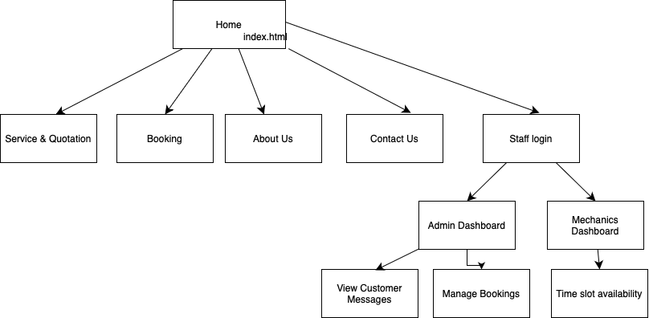

Figure 1 Navigation Structure of City Centre Garage Website

In the website header navigation structure, there are mainly divided into five different key pages which is Service & Quotation, Booking, About Us, Contact Us and Staff Login. Inside the staff login, there are two different login which is Admin and Mechanics. For Admin, they will have pages of view customer messages and manage booking. Mechanics will have time slot availability page.

## 2.2 Configuring CSS Model

## 2.3 Storyboard of the website

## 2.4 HTML, CSS, JS code

# 3. Test & Implementation

Testing would be needed to ensure that the HTML ,CSS, JS are writing . The test would be including unit testing, integration testing and system as we need to test different scenario to ensure the website works as expected

## 3.1 Unit testing

## 3.2 Integration Testing

We need to do data integration testing as we need to check that all table and relationships work correctly which according to the relational model primary key, foreign key and the constraints.

## 3.3 System Testing

# 4. Website Evaluation & Review (UAT)

# 5. References

Dylag, J. (n.d.). *Grayscale photo of person playing piano*. [online image] Available at: <https://unsplash.com/photos/grayscale-photo-of-person-playing-piano-Fd6osyVbtG4> [Accessed 16 Apr. 2025].

Reyes, B. (n.d.). Red car parked on the street. [online image] Available at: <https://unsplash.com/photos/red-car-QzH-UGjKN8g> [Accessed 16 Apr. 2025].

Brosnan, T. (n.d.). Man refilling motor oil on car engine bay. [online image] Available at: <https://unsplash.com/photos/man-refilling-motor-oil-on-car-engine-bay-V37iTrYZz2E> [Accessed 16 Apr. 2025].

Shalaby, A. (n.d.). Man in white shirt standing beside black car. [online image] Available at: <https://unsplash.com/photos/man-in-white-shirt-standing-beside-black-car-bEGTsOCnHro> [Accessed 16 Apr. 2025].

He, R. (n.d.). Boy’s face close-up photography. [online image] Available at: <https://unsplash.com/photos/boys-face-close-up-photography-n4KewLKFOZw> [Accessed 16 Apr. 2025].

Bashir, M. (n.d.). Man wearing black crew neck shirt. [online image] Available at: <https://unsplash.com/photos/man-wearing-black-crew-neck-shirt-d2MSDujJl2g> [Accessed 16 Apr. 2025].

Arif, I. (n.d.). Smiling woman wearing white and black pinstriped collared top. [online image] Available at: <https://unsplash.com/photos/smiling-woman-wearing-white-and-black-pinstriped-collared-top-QXevDflbl8A> [Accessed 16 Apr. 2025].